

Windows Workflow Foundation

Hands-On Lab

Lab Manual
Lab 01 – Getting Started with Windows Workflow Foundation in Visual Basic 2005

Converted from C# to Visual Basic.NET courtesy of:
Microsoft MVP Ken Kam Hung Lin.

Information in this document, including URL and other Internet Web site references, is subject to change without notice. This document supports a preliminary release of software that may be changed substantially prior to final commercial release, and is the proprietary information of Microsoft Corporation.

This document is for informational purposes only. MICROSOFT MAKES NO WARRANTIES, EITHER EXPRESS OR IMPLIED, AS TO THE INFORMATION IN THIS DOCUMENT.

The entire risk of the use or the results from the use of this document remains with the user. Complying with all applicable copyright laws is the responsibility of the user. Without limiting the rights under copyright, no part of this document may be reproduced, stored in or introduced into a retrieval system, or transmitted in any form or by any means (electronic, mechanical, photocopying, recording, or otherwise), or for any purpose, without the express written permission of Microsoft Corporation.

Microsoft may have patents, patent applications, trademarks, copyrights, or other intellectual property rights covering subject matter in this document. Except as expressly provided in any written license agreement from Microsoft, the furnishing of this document does not give you any license to these patents, trademarks, copyrights, or other intellectual property.

Unless otherwise noted, the example companies, organizations, products, domain names, e-mail addresses, logos, people, places and events depicted herein are fictitious, and no association with any real company, organization, product, domain name, email address, logo, person, place or event is intended or should be inferred.

© 2007 Microsoft Corporation. All rights reserved.

Microsoft, MS-DOS, Windows, Windows NT, Windows Server, Visual Basic 2005 and Visual Studio are either registered trademarks or trademarks of Microsoft Corporation in the United States and/or other countries.

The names of actual companies and products mentioned herein may be the trademarks of their respective owners.
Contents
Lab 01: Getting Started with Windows Workflow Foundation 2
Lab Objective 2
Exercise 1 – Create a Hello World Workflow 3
Task 1 – Create a new Workflow Project 3
Task 2 – Add a code activity 5
Task 3 – Run the new workflow with Debugging 7
Exercise 2 – Receiving Data into the Workflow using Parameters 10
Task 1 – Define parameters for the workflow 10
Task 2 – Modify the Code Activity 11
Task 3 – Execute the modified workflow 12
Exercise 3 – Using the If/Else activity, declarative conditions and custom activities 17
Task 1 – Create a new Workflow Project 17
Task 2 – Add the Expense Reporting Interface to the Project 19
Task 3 – Add the ExpenseReportSubmitted activity 21
Task 4 – Add the pre-built AutoApprove activity to the workflow 24
Task 4 – Add a Rule Condition to the workflow 25
Task 5 – Add the logic to approve or reject the expense report 27
Task 6 – Configure the ExpenseWorkflows project for debugging 28
Task 7 – Test the Expense Reporting Workflow 30
Exercise 4 – Using Listen, Delay, and event-based custom activities 34
Task 1 – Add activities for requesting manager approval 34
Task 2 – Add a Listen activity for waiting for the Expense Report Review 36
Task 3 – Approve or Reject the Expense Report 39
Task 4 – Test the Expense Reporting Workflow 46
Lab Summary 50

Lab 01: Getting Started with Windows Workflow Foundation
Estimated time to complete this lab: 60 minutes
The project files for this lab are in the c:\Windows Workflow Foundation\Labs\VB\Lab01 folder. Completed solutions for each exercise can be found in the Completed subdirectory. Resource files referenced in these labs can be found in the Resources subdirectory. All code snippets in this lab manual that are longer than two lines are available on the lab machine as Microsoft Visual Studio 2005 Code Snippets. To access these you can right click your mouse in the code editor and choose Insert Snippet… The code snippets associated with this lab are accessed in My Code Snippets | Lab01.
More information about Windows Workflow Foundation can be found at http://msdn.microsoft.com/workflow

Lab Objective
The objective of this lab is to introduce the key Windows Workflow Foundation workflow concepts. After completing this lab, you will be able to:
- Author Sequential Workflows using the Visual Studio 2005 designer for Windows Workflow Foundation
- Configure and use the Visual Studio 2005 debugger to debug your workflows
- Receive parameters into a workflow
- Receive an event to activate a new instance of a workflow
- Define conditions
- Configure basic activities including If/Else, Delay, Listen, and Code
- Utilize custom activities for receiving events into a workflow

A workflow is a model of a human or system process which is defined as a map of activities. An activity is a step in a workflow and is the unit of execution, re-use and composition for a workflow. A workflow is designed by laying out activities and is compiled to a .NET assembly that is executed on the workflow runtime and the Common Language Runtime (CLR).

Exercise 1 – Create a Hello World Workflow
In this exercise, you will create a very simple “Hello World” workflow using the Visual Studio 2005 designer for Windows Workflow Foundation, referred to as the Visual Studio workflow designer in the remainder of this document. The Hello World workflow will be a sequential workflow that includes a single code activity. The code activity will be used to write the phrase “Hello, World!” to the console at runtime. You will explore the workflow definition and the code-beside for the workflow. Finally, you will see how to execute your workflow using a simple host and debug your workflow using Visual Studio 2005.

Task 1 – Create a new Workflow Project

- Open Visual Studio 2005 by going to the Start Menu | Programs | Microsoft Visual Studio 2005 | Microsoft Visual Studio 2005
- In Visual Studio 2005, select the File | New | Project menu command.
- Visual Studio 2005 will display the New Project dialog window.
- In the New Project dialog window, expand Visual Basic | Workflow in the Project Types tree on the left side.
- Select the template named “Sequential Workflow Console Application” and enter the following values:
Name: HelloWorldWorkflow
Location: C:\Windows Workflow Foundation\Labs\VB\Lab01

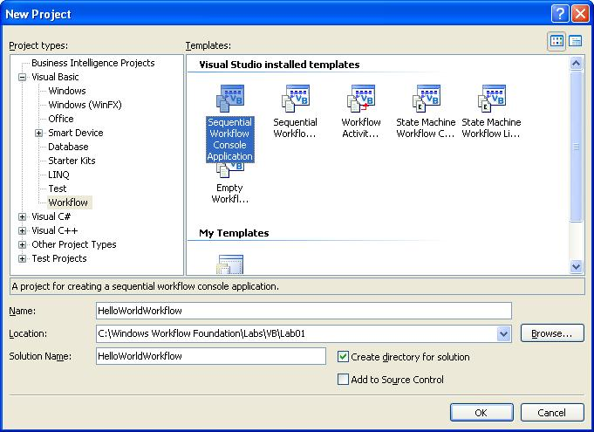

- You should now have a new solution and workflow project.
- The project template has a Workflow1.vb which we will remove as we will be using a simpler kind of workflow for this lab. Click on Workflow1.vb and press the DEL key. Click the okay button to confirm.
- Right click on the HelloWorldWorkflow project in Solution Explorer and select Add | New Item from the context menu.
- In the Add New Item dialog window, select the item template named Sequential Workflow (with code separation) and click the Add button to add the new workflow to the HelloWorldWorkflow project.
Note: It may be easier to read the template names if you change the view of the Add New Item dialog to large Icons by clicking on the toolbar icon in the upper right corner.

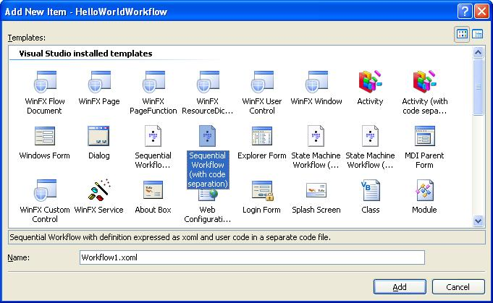

- The new Sequential Workflow project will now contain two files: Workflow1.xoml and Workflow1.xoml.vb. Workflow1.xoml contains the XML markup that represents the workflow type. Workflow1.xoml.vb contains the code-beside class for the workflow. Make sure “Show All Files” is selected in the Solution Explorer.

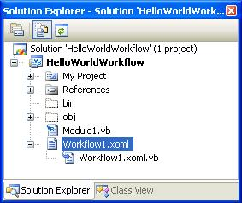

Task 2 – Add a code activity

- Double click on the Workflow1.xoml file in Solution Explorer to open the Visual Studio workflow designer.
- In the workflow designer, select the View | Toolbox menu command to display the toolbox with available activities.
- You may need to expand the Windows Workflow category in the toolbox to view the Windows Workflow Foundation activities.
- Select the Code activity from the toolbox.
- Drag and drop the Code activity to the design surface for the Sequential Workflow.
- Notice the red exclamation mark on the new Code activity. Click the exclamation mark to view the smart tag and the reason for why it’s being displayed.

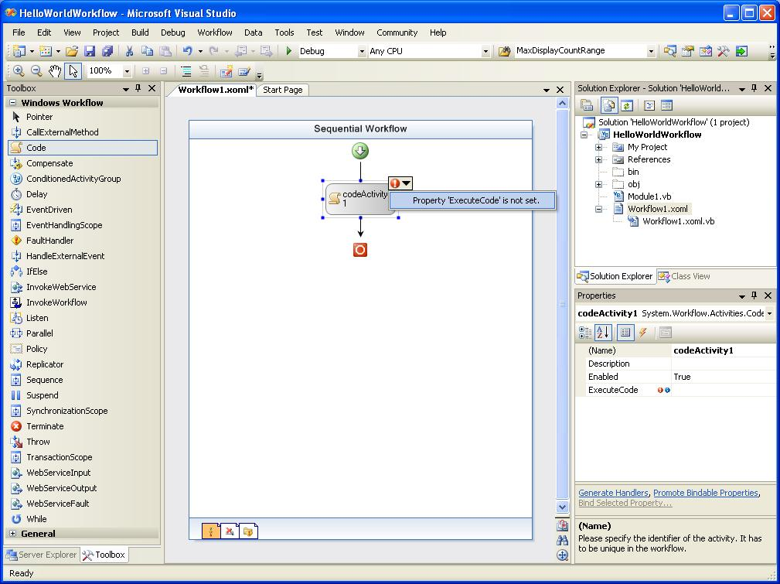

- Selecting the smart tag will cause the Properties tool window to be displayed with the ExecuteCode property highlighted.
- Enter the value codeActivity1_CodeHandler for the ExecuteCode property and press Enter.
- This will cause a new method or handler to be added to the code-beside class for the workflow. Visual Studio will automatically open the Workflow1.xoml.vb code file and display the new codeActivity1_CodeHandler method. Alternatively, you can switch from the design view to the code- for the workflow by double-clicking on the activity or by selecting the View | Code menu item.
- The code-behind class is a partial class that inherits from the SequentialWorkflowActivity base class. This code-behind class will have the same name as the workflow. You should have the following code in your code-beside class:

'NOTE: When changing the namespace;
'please update XmlnsDefinitionAttribute in AssemblyInfo.vb
Public Class Workflow1
Inherits SequentialWorkflowActivity

Private Sub codeActivity1_CodeHandler(ByVal sender As System.Object, _
ByVal e As System.EventArgs)

End Sub
End Class

- Insert the following code in the codeActivity1_CodeHandler method to output the string “Hello, World!” to the console:

Private Sub codeActivity1_CodeHandler(ByVal sender As System.Object, _
ByVal e As System.EventArgs)
Console.WriteLine("Hello, World!")
End Sub

- Select the Build | Build Solution menu command to compile and build your project. Verify that there are no compiler errors or warnings.

Task 3 – Run the new workflow with Debugging

For this exercise we are going to use the simple host in Module1.vb that comes with the project template that was selected. Alternatively, you could build your own workflow host application by using the workflow runtime APIs defined in the System.Workflow.Runtime namespace.

- Open the Visual Studio workflow designer by double clicking on workflow1.xoml in the solution explorer.
- Click on the codeActivity1 activity to select it and set a breakpoint on it.
- To set the breakpoint right-click on the code1 activity and choose Breakpoint | Insert Breakpoint.
- You should now see a red circle to the left of the code1 activity.

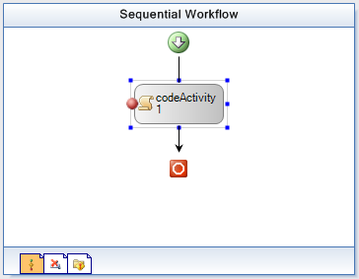

- Compile and run the solution under the Visual Studio debugger by pressing F5 (or selecting the Debug | Start Debugging menu command).
- The HelloWorldWorkflow will start a workflow instance and that instance will break in the debugger when it gets to the code activity. The yellow box indicates the activity that the debugger is stopped at

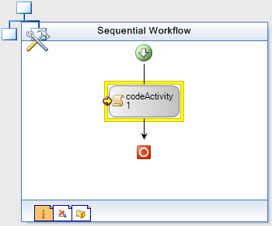

- Choose Debug | Step Into from the menu and the debugger will step into the start of the codeActivity1_CodeHandler method.

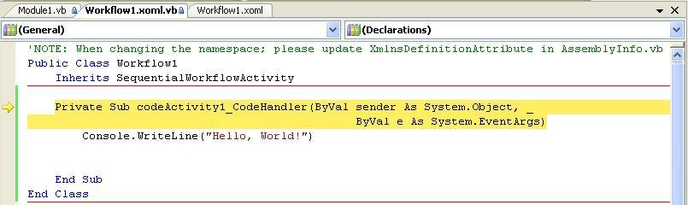

- Choose Debug | Step Into a couple of more times and you should see “Hello, World!” written out into the test host’s console window.
- The workflow will now complete and the program finishes.

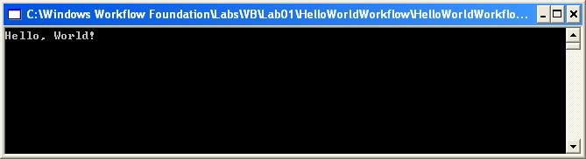

Exercise 2 – Receiving Data into the Workflow using Parameters
In this exercise, you will modify the workflow we created in Exercise 1 to receive data into our workflow when it is started. You will also modify the code in our Code activity’s handler to display the input values. Finally, you will change our startup project to use a Windows Forms (WinForms) host that will allow us to enter the input values and create an instance of our workflow.

Note: There are two general approaches for receiving data into a workflow when it is started. They are Parameters and Events. With parameters, a list of parameter names and types are defined with the workflow. These parameter values are passed in by a host when it starts a new instance of the workflow type. With events, workflow authors add an activity that receives an event and data associated with the event. Events are generally specific to the host and custom activities that have been designed to handle the event. We’ll use parameters in this exercise and learn how to use event-based activities in Exercise 3.

Task 1 – Define parameters for the workflow

- In Visual Studio 2005 with the HelloWorldWorkflow project open, double click on the Workflow1.xoml file in Solution Explorer to open the Visual Studio workflow designer.
- Right-click the workflow background in the Visual Studio workflow designer and click View Code, or select the View | Code menu item.
- Inside the Workflow1 class, type “property” and followed by TAB key,

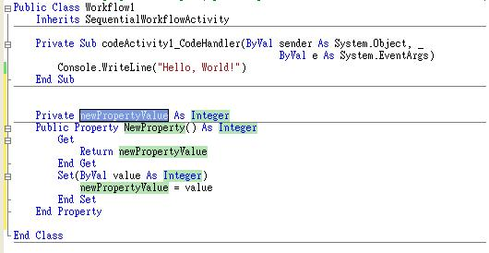

- Fill in each of the highlighted areas in the snippet to create a string property called FirstName with a private member called myFirstName as shown below.

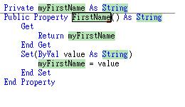
- Use the same technique to include another string property called LastName with the private member mylastName.

Task 2 – Modify the Code Activity

- In this exercise we will use a Windows Forms application as the workflow host. Since we want to display a message box from the workflow application, we need to add a reference to the assembly for Windows Forms. Select the Project | Add Reference menu item.
- On the .NET tab in the Add Reference dialog, select System.Windows.Forms from the list of assemblies and click the OK button.

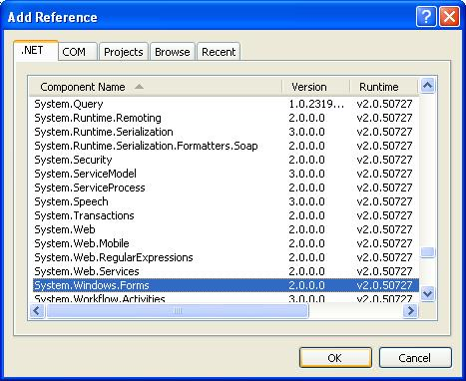

- Right click on the Workflow1.xoml.vb file in Solution Explorer and select the View Code menu item from the context menu. Navigate to the method codeActivity1_CodeHandler in the Workflow1.xoml.vb source file. This method is the code handler for the code activity in the workflow.
- Modify the code in the codeActivity1_CodeHandler method to get the parameter values and display a Message Box with the FirstName and LastName values:

Private Sub codeActivity1_CodeHandler(ByVal sender As System.Object, _
ByVal e As System.EventArgs)
System.Windows.Forms.MessageBox.Show _
("Hello world: " & myFirstName & " " & myLastName);
End Sub

Task 3 – Execute the modified workflow
Now we’re ready to test the modified workflow. Instead of using a console host application as we did in Exercise 1, in this exercise we’re going to add a new Windows Forms application and some pre-written code as a host for our workflow.

- In Visual Studio 2005, with the HelloWorldWorkflow solution open, add a new project, WinFormTestHost to the solution by selecting the File | Add | New Project menu item as shown below:

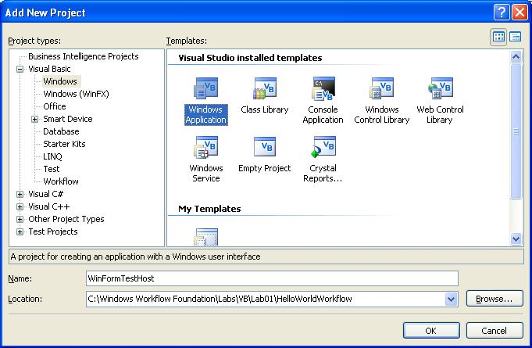

- Right click and select Delete to remove Form1.vb from the new WinFormTestHost project.
- Right click on the WinFormTestHost project and select Add | Existing Item…. Select and add all the files from the following directory (as shown below):

C:\Windows Workflow Foundation\Labs\VB\Lab01\Resources\WinFormTestHost Files

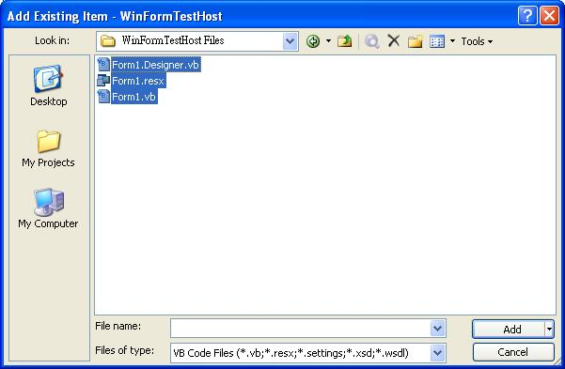

- Using the Solution Explorer tool window, right click on the WinFormTestHost project and select Set as Startup Project from the context menu.

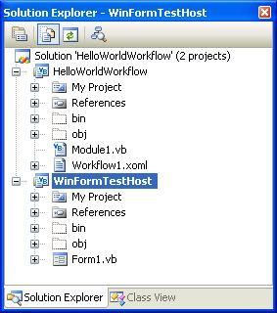

- Now we need to make sure that the WinFormTestHost application can use the new workflow. Add a reference to the HelloWorldWorkflow project by right clicking on the References folder for the WinFormTestHost in Solution Explorer and selecting Add Reference from the context menu.
- In the Add Reference dialog window, select the Projects tab.
- Select the HelloWorldWorkflow project from the list and press the OK button to close the Add Reference dialog window and add the new reference.

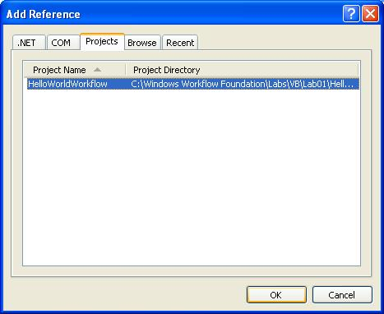

- We also need to ensure that the WinFormTestHost has references to the Windows Workflow Foundation system assemblies. Add these references by right clicking on the References folder for the WinFormTestHost in Solution Explorer and selecting Add Reference from the context menu
- In the Add Reference dialog window, select the .NET tab, scroll down and select the entries shown below and click OK.

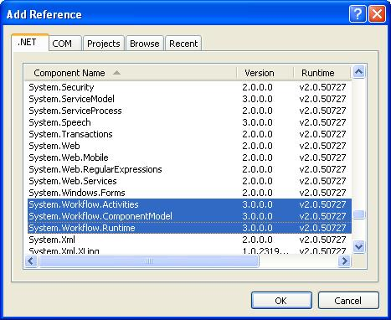

- Right click on the Workflow1.xoml.vb file in Solution Explorer and select the View Code menu item from the context menu to open the code-beside class for the workflow.
- Set a breakpoint in the codeActivity1_CodeHandler method.
- Compile and run the solution under the Visual Studio debugger by pressing F5 or selecting the Debug | Start Debugging menu command.
- The WinFormTestHost will start and display a window containing fields for entering a First and Last Name.
- Enter values in the First name and Last name fields
- Click the Start Workflow button to instantiate a new instance of the HelloWorldWorkflow.Workflow1 and pass in the First name and Last name values as parameters.

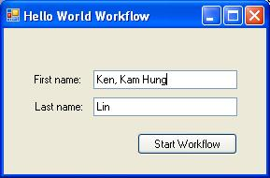

- Visual Studio 2005 will then break into debug mode for the codeActivity1_CodeHandler method. Continue execution of the workflow by selecting the Debug | Continue menu item.

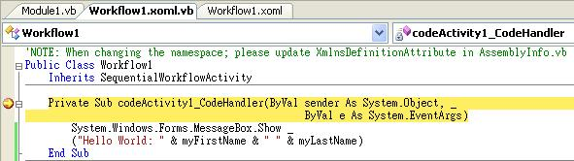

- When the code activity finishes executing you will see a message box with the first name and last name were passed as parameters to the workflow.

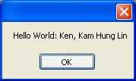

- Close the WinFormTestHost application to stop the host and stop the debugger.

Exercise 3 – Using the If/Else activity, declarative conditions and custom activities

In this exercise you will learn how to utilize the IF/Else activity and a declarative condition in the workflow to perform conditional processing. You will also learn how to use custom activities within a workflow. You will learn these concepts by building a simple sequential workflow for processing an expense report. The workflow will receive an event when the Expense Report is submitted. The event arguments will contain the actual expense report to process. If the amount of the expense report is less than $1000, then we will automatically approve it. However, if it is $1000 or greater, then we will automatically reject the expense report.

To simplify this lab and focus on workflow authoring concepts, you will be provided with the custom Expense Reporting activities, workflow host, and Windows Application for submitting an expense reports to the workflow.
Because some of the parts of this lab exercise are predefined you must be sure to use the project name ExpenseWorkflows as listed below. Otherwise your lab will not work as expected.

Task 1 – Create a new Workflow Project

- Open Visual Studio 2005 by going to the Start Menu | Programs | Microsoft Visual Studio 2005 | Microsoft Visual Studio 2005
- In Visual Studio 2005, select the File | New | Project menu command.
- Visual Studio will display the New Project dialog window.
- In the New Project dialog window, expand Visual Basic | Workflow in the Project Types tree on the left side.
- Select the template named Empty Workflow Project and enter the following values for the name and location:

Name: ExpenseWorkflows

Location: C:\Windows Workflow Foundation\Labs\VB\Lab01

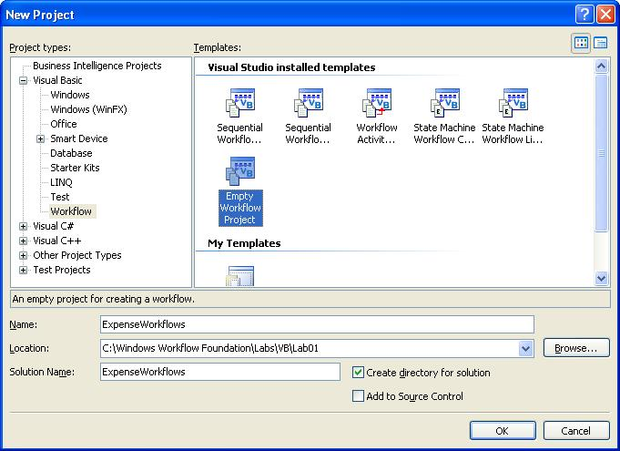

- You should now have a new solution and workflow project. Now we need to add a new Sequential Workflow to the project.
- Select the Project | Add Sequential Workflow menu item. This will cause Visual Studio to display the Add New Item dialog window.
- In the Add New Item dialog window, select the workflow template named Sequential Workflow (with code seperation) and use the default workflow name of Workflow1.xoml.

- Two new files named Workflow1.xoml and Workflow1.xoml.vb will now be added to your ExpenseWorkflows project. Workflow1.xoml contains the XML workflow markup that represents the workflow definition. Workflow1.xoml.vb contains the code-beside class for the workflow.

Task 2 – Add the Expense Reporting Interface to the Project

- We will use the HandleExternalEvent and CallExternalMethod activities to interface the expense reporting. Before we can begin doing this, we also need to add a reference to a dependency assembly. In Visual Studio 2005 with the ExpenseWorkflows project open, select the Project | Add Reference menu item.
- In the Add Reference dialog window, select the Browse tab.
- Enter or browse to the ExpenseLocalServices.dll assembly located in the following directory:

C:\Windows Workflow Foundation\Labs\VB\Lab01\Resources\ExpenseReporting\bin
- Press the OK button to close the Add Reference dialog window and add the new reference.

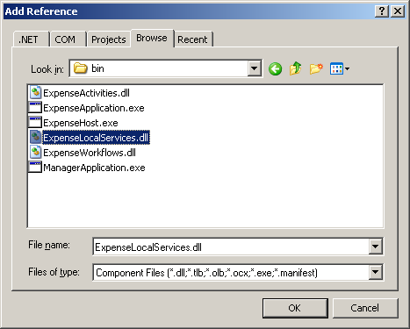

Task 3 – Add the ExpenseReportSubmitted activity

- In the Workflow1 class we need to create two member variables. One variable named reportArgs will be used to hold a reference to ReportSubmitted’s event arguments, that contains the report object. The second variable will be used to hold the expense amount for the report that was submitted. We’ll use these variables later in our workflow.
- Right-click on Workflow1.xoml.vb and choose View Code. Add the following lines. (note: a code snippet is available for this)

(Snippet: Lab01_Ex03_Task03_MemberVariables)
'NOTE: When changing the namespace;
'please update XmlnsDefinitionAttribute in AssemblyInfo.vb
Public Class Workflow1
Inherits SequentialWorkflowActivity

Public reportArgs As ExpenseLocalServices.ExpenseReportSubmittedEventArgs
Public Amount As Integer

End Class

- Double click on the file workflow1.xoml in the solution explorer to return to the Visual Studio workflow designer.
- In the Visual Studio workflow designer, select the View | Toolbox menu command to display the toolbox with available activities.
- Select the HandleExternalEvent activity and drag and drop it onto the workflow design surface.
- Set the (Name) property for the HandleExternalEvent property to expenseReportSubmitted1.
- Your workflow should look like this:

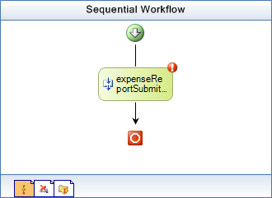

- Click on the red exclamation point (smart tag) on the new activity and select the menu item labeled Property ‘InterfaceType’ is not set.

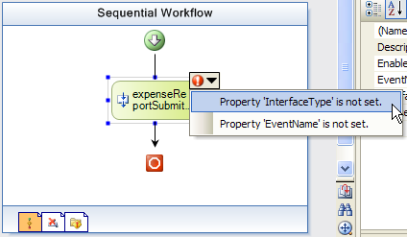

- Click on the InterfaceType property. Click the […] button to show the .NET Type Browser dialog. Choose ExpenseLocalServices.IExpenseService from the Referenced Assemblies tree.

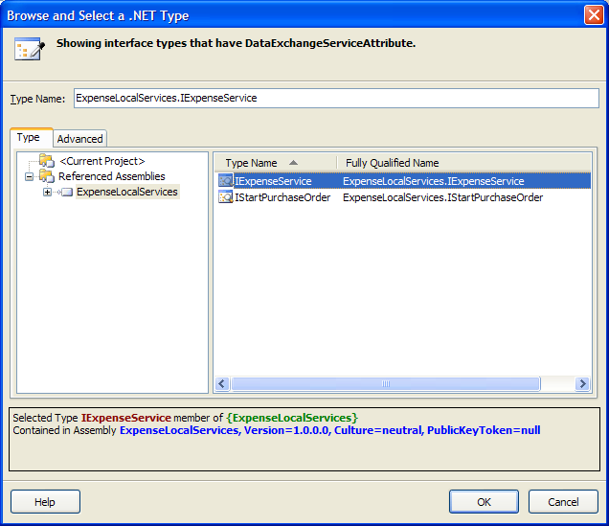

- Click OK to close the .NET Type Browser dialog.
- In the properties window for expenseReportSubmitted1, use the drop-down menu for EventName to select ExpenseReportSubmitted.
- Click on the e property, then click the ellipsis which will bring up the following screen property binding interface:

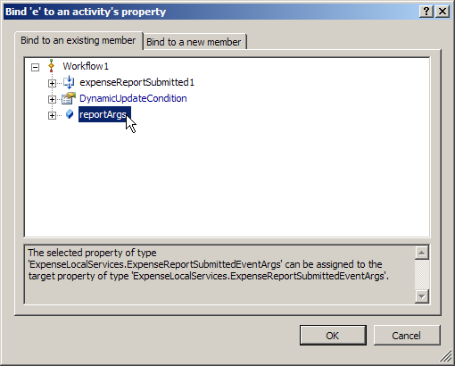
- Select reportArgs and click OK.
- For the Invoked property, enter the value ReportSubmitted_Invoked and press Enter to be taken to the code-beside file. Before pressing Enter, the properties window should look like this:

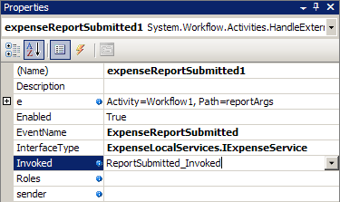

- Add code in the ReportSubmitted_Invoked method to write the method name to the console and set the amount variable using the data from the event. The code should read as follows:

(Snippet: Lab01_Ex03_Task03_ReportSubmittedInvoked)
Private Sub ReportSubmitted_Invoked(ByVal sender As System.Object, _
ByVal e As System.Workflow.Activities.ExternalDataEventArgs)

Console.WriteLine("ReportSubmitted_Invoked")
Me.Amount = Me.reportArgs.Report.Amount

End Sub

Task 4 – Add the pre-built AutoApprove activity to the workflow

- We will need to add a pre-built custom activity that will calculate whether a submitted report can be automatically approved. The AutoApprove activity will do this for us using its AutoApprovalPolicy activity, but first we need to add it to the toolbox so that we can use it in the designer.
- Select Tools | Choose Toolbox Items… from the menu.
- Select the .NET Framework Components tab and click the Browse button.
- Navigate to the directory below and open ExpenseActivities.dll.

C:\Windows Workflow Foundation\Labs\VB\Lab01\Resources\ExpenseReporting\bin
- Click OK on the Choose Toolbox Items form.
- Right click on the Workflow1.xoml file in Solution Explorer and select the View Designer menu item from the context menu to switch back to the Visual Studio workflow designer.
- There should be two new activities available for our workflow now, AutoApprove and GetManager. Drag AutoApprove onto your workflow after expenseReportSubmitted1. Your workflow should now look like the picture below.

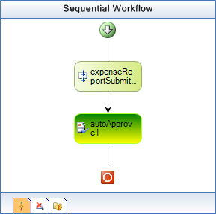

- Select the new autoApprove1 activity.
- In the Amount property for autoApprove1, click on the ellipsis to bind the property to Workflow1.amount.

Task 4 – Add a Rule Condition to the workflow

A rule condition is a condition statement that is created in a dialog and stored as XML with the workflow. It can include predicates that compare workflow state and Boolean algebra combining multiple predicates. The conditions can be used in various activities including IfElse, While, ConditionedActivityGroup, and Replicator.

- Right click on the Workflow1.xoml file in Solution Explorer and select the View Designer menu item from the context menu to switch back to the Visual Studio workflow designer.
- Select the IfElse activity from the toolbox and add it to the workflow below the autoApprove1 activity.
- Select the new IfElse activity and set the (Name) property for the activity to EvaluateExpenseReport.
- Select the left section of the IfElse activity labeled ifElseBranchActivity1.
- In the properties window enter or select values for the following properties:
  - (Name) – Enter the value IfAutoApproveReport
  - Condition – Select Declaritive Rule Condition from the drop down list.
- Click the plus [+] to expand the Condition property in the properties window and enter the value AutoApproveCondition for the ConditionName.
- Enter the Expression property by clicking on the ellipsis to bring up the Rule Condition Editor, as shown below.

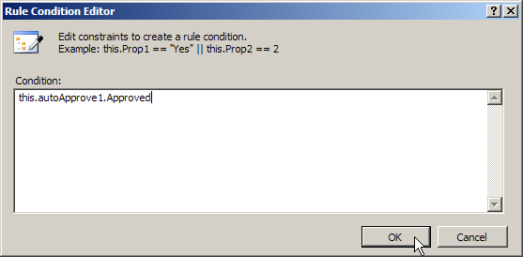

- Enter this.autoApprove1.Approved in the condition box and click OK.

Note: If you click on the ellipses next to the Name property you will view a dialog window that allows you to manage the declarative conditions. Try this feature next time you create conditions in workflows.

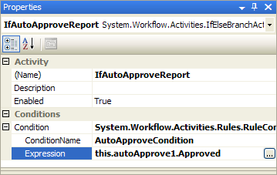

- In the Visual Studio workflow designer, select the right section of the EvaluateExpenseReport activity labeled ifElseBranchActivity2.
- In the properties window, set the (Name) property for the branch to the value ElseRejected.

Task 5 – Add the logic to approve or reject the expense report

- Select the CallExternalMethod activity from the toolbox and drag and drop it onto the workflow design surface inside of the branch labeled IfAutoApproveReport.
- Set the Name property of the new activity to approveExpenseReport1.
- Choose the InterfaceType property the same as for the HandleExternalEvent activity in Task 3. Do this by selecting ExpenseLocalService.IExpenseService from the dialog that you get when you click the ellipses […] next to InterfaceType.
- Choose the MethodName and select ApproveExpenseReport from the drop down list.
- Also in the properties window enter or select values for the following properties:
  - report – Click the ellipsis to bind this to reportArgs.Report, as shown in the screen below:

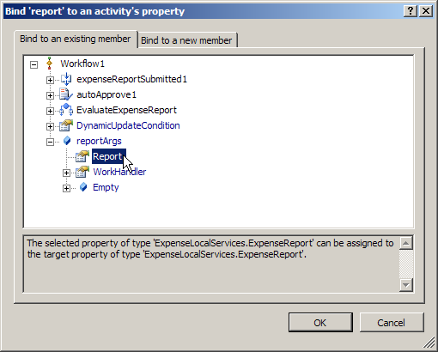
- Add another CallExternalMethod activity to the workflow definition by dragging and dropping it into the ElseRejected branch of our IfElse activity.
- Set the Name property of the new activity to rejectExpenseReport1.
- Choose the InterfaceType property. Again select ExpenseLocalService.IExpenseService.
- Choose the MethodName property and select RejectExpenseReport from the drop down list.
- Choose the Report property and bind it to reportArgs.Report.

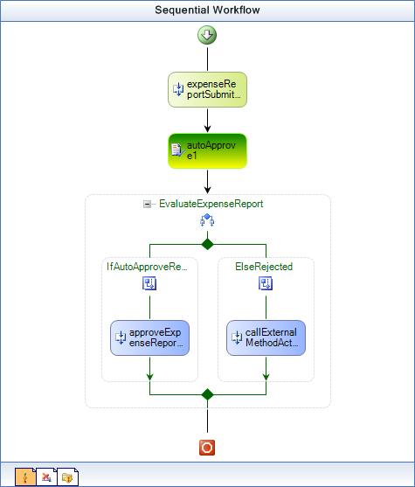

Task 6 – Configure the ExpenseWorkflows project for debugging

- Using Windows Explorer navigate to the following directory:
- C:\Windows Workflow Foundation\Labs\VB\Lab01\Resources\ExpenseReporting\bin
- Copy the files ExpenseHost.exe and ExpenseHost.exe.config to the following directory:

C:\Windows Workflow Foundation\Labs\VB\Lab01\ExpenseWorkflows\ExpenseWorkflows\
bin\
- Now we need to change the startup application for the ExpenseWorkflows project to our test host. Right click on the ExpenseWorkflows project in Solution Explorer and select Properties from the context menu.
- The Project Properties window will now be displayed. Select the Debug tab in the Project Properties window
- Change the Start Action to Start External Program and enter or browse to our test host located in the following path:
C:\Windows Workflow Foundation\Labs\VB\Lab01\ExpenseWorkflows\ExpenseWorkflows\
bin\ExpenseHost.exe

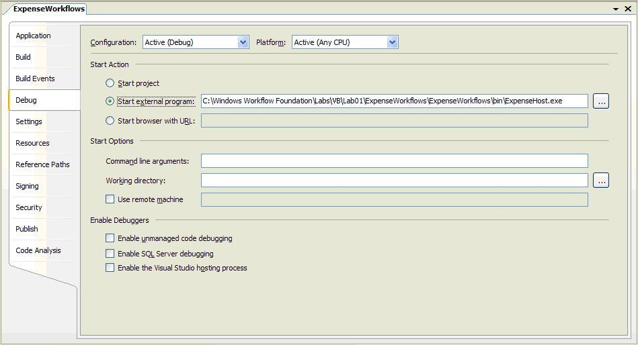

- Press CTRL-S to save the settings.
- Double-click on the Workflow1.xoml file in Solution Explorer to open the Visual Studio workflow designer for the workflow.
- Set a breakpoint on the expenseReportSubmitted1 activity at the top of the workflow. Do this by right-clicking on the activity and choosing Breakpoint | Insert Breakpoint.

Task 7 – Test the Expense Reporting Workflow

- Compile and run the ExpenseWorkflows project under the Visual Studio debugger by pressing F5 or selecting the Debug | Start Debugging menu command.
- The ExpenseHost will then start and display a console window. It is waiting for Expense Reports to be submitted from the ExpenseApplication.

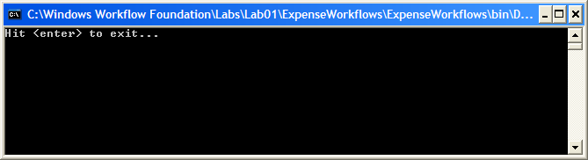

- Run the ExpenseApplication.exe located in the following directory:

C:\Windows Workflow Foundation\Labs\VB\Lab01\Resources\ExpenseReporting\bin
- Using the Expense Application, click the Submit Report button to create a new expense report using the default values on the form and submit it to the workflow.

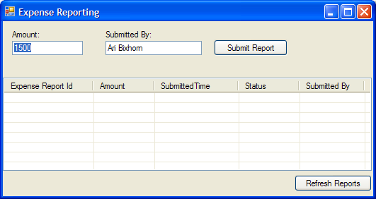

Note: You may get a failure in debugging from Visual Studio when you click the Submit Report button in the Expense Application. To avoid this check and set these debugging settings:
  - Tools | Options | Debugging | General
Uncheck the box labeled “Redirect all console output to the Quick Console window”.
  - Tools | Options | Debugging | Edit and Continue
Uncheck the box labeled “Enable Edit and Continue”.
  - Tools | Options | Debugging | Just-In-Time
Ensure that the boxes labeled “Managed” and “Workflow” are checked.

- Visual Studio 2005 will break into debug mode on the expenseReportSubmitted1 activity.

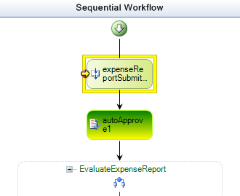

- Use F11 (or Debug | Step Into) and you will step to the ReportSubmitted_Invoked handler code.

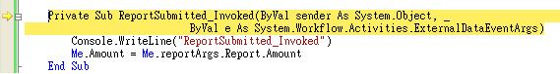

- Use F11 (or Debug | Step Into) to continue stepping through the code and the workflow until you come to the rejectExpenseReport1 activity.

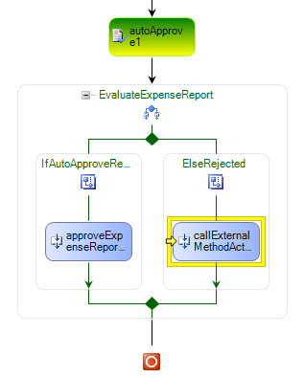

- Now press F5 (or Debug | Continue) to complete the workflow instance.
- In the Expense Reporting application, click the Refresh button to view the status for the expense report that was just submitted. Notice that the status is rejected because the amount for the expense report was $1500 (by default) and only expense reports less than $1000 are automatically approved.
- Submit another expense report with an amount of $500 and you will hit the debug breakpoint again. Use F5 (or Debug | Continue) to complete the workflow and notice that the report is automatically approved.

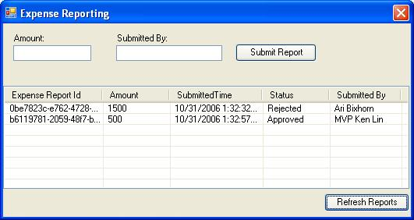

- The workflow will now complete. You can now close the Expense Reporting application.
- Stop the ExpenseHost console application and stop debugging the ExpenseWorkflows project by selecting the Debug | Stop Debugging menu item in Visual Studio.

Exercise 4 – Using Listen, Delay, and event-based custom activities

In this exercise you will extend the Expense Reporting workflow you created in Exercise 3 to provide the ability for a manager to approve or reject expense reports that are greater than $1000. You will utilize a few additional activities including Listen, Delay, and some additional custom activities.

Task 1 – Add activities for requesting manager approval

- Right click on workflow1.xoml.vb in the solution explorer and choose View Code.
- Add declarations for ReportEmployeeId, ManagerEmployeeId and reviewArgs to the start of the Workflow1 class.

(Snippet: Lab01_Ex04_Task01_MemberVariables)
Public ReportEmployeeId As String
Public ManagerEmployeeId As String
Public reviewArgs As ExpenseLocalServices.ExpenseReportReviewedEventArgs

- In Visual Studio 2005, open the Workflow1.xoml file in the Visual Studio workflow designer by right clicking on it in Solution Explorer and selecting View Designer from the context menu.
- Right click on the rejectExpenseReport1 activity and select Delete from the context menu.
- Select the right branch of the EvaluateExpenseReport IfElse activity (presently called ElseRejected) and in the properties window, change the (Name) property for the branch to the value ElseManagerApproval.
- Add a GetManager (from ExpenseActivities.dll that we added to the toolbox in exercise 3) activity to the workflow definition by dragging and dropping it out of the toolbox into the ElseManagerApproval branch of our IfElse activity.

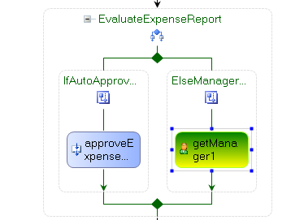

- In the properties window enter or select values for the following properties:
  - ManagerEmployeeId – Click the ellipsis to bind this to ManagerEmployeeId
  - ReportEmployeeId – Click the ellipsis to bind this to ReportEmployeeId
- Change the code in the ReportSubmitted_Invoked method to set the ReportEmployeeId to the value provided in the Expense Report’s EmployeeId property. Add the highlighted line of code below.

Private Sub ReportSubmitted_Invoked(ByVal sender As System.Object, _
ByVal e As System.Workflow.Activities.ExternalDataEventArgs)

Console.WriteLine("ReportSubmitted_Invoked")
Me.Amount = Me.reportArgs.Report.Amount
me.ReportEmployeeId = me.reportArgs.Report.EmployeeId
End Sub

- Double-click on the Workflow1.xoml file in Solution Explorer to switch back to the Visual Studio workflow designer.
- Add a CallExternalMethod activity to the workflow just below the getManager1 activity by dragging and dropping it out of the toolbox onto the Visual Studio workflow designer.
- Set the Name property of the CallExternalMethod activity to requestManagerApproval1
- Choose the InterfaceType property first. Select ExpenseLocalServices.IExpenseService.
- Choose the MethodName and select RequestManagerApproval from the drop down list.
- Also, in the properties window enter or select values for the following properties:
  - ManagerEmployeeId – Click the ellipsis to bind this to ManagerEmployeeId.
  - Report - Click the ellipsis to bind this to reportArgs.Report.

- EvaluateExpenseReport should now look like this:

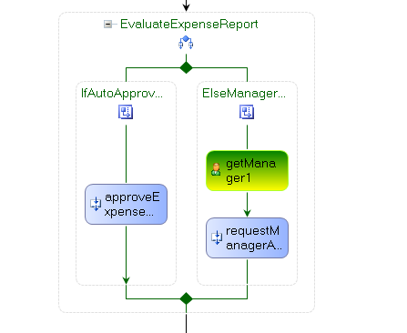

Task 2 – Add a Listen activity for waiting for the Expense Report Review

- Add a Listen activity to the workflow definition below the requestManagerApproval1 activity by dragging and dropping it out of the toolbox onto the Visual Studio workflow designer.
- In the properties window, change the (Name) property for listenActivity1 activity to the value ListenForManagerApproval.
  - Change the (Name) property for the eventDrivenActivity1 section of the Listen activity to ManagerReviewed
  - Change the (Name) property for the eventDrivenActivity2 section of the Listen activity to ReviewTimeout
- The part of your workflow definition that we are editing should look like this:

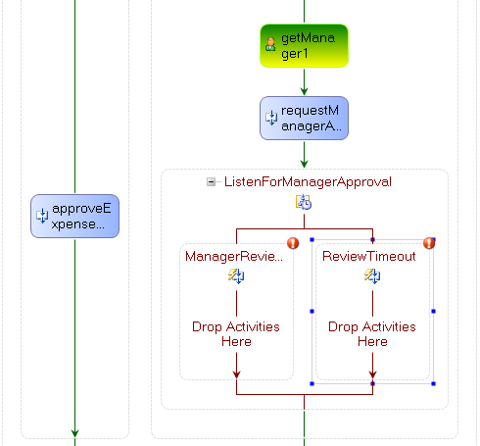

- Add a HandleExternalEvent activity to the workflow definition within the ManagerReviewed section by dragging and dropping the activity out of the toolbox onto the Visual Studio workflow designer.
- Set the Name for the HandleExternalEvent activity to expenseReportReviewed1.
- With the new expenseReportReviewed1 activity selected, navigate to the properties window.
- Choose the InterfaceType property first. Select ExpenseLocalServices.IExpenseService.
- Choose the EventName and select ExpenseReportReviewed from the drop down list.
- Also, in the properties window enter or select values for the following properties:
  - e – Click the ellipsis to bind this to reviewArgs.
- Your workflow definition should look like this:

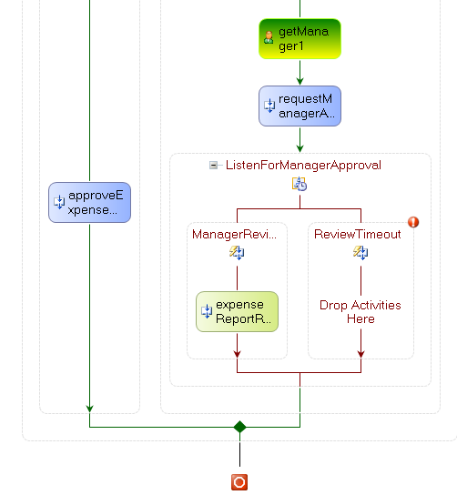

- Select the Delay activity from the toolbox and drag and drop it onto the workflow design surface within the ReviewTimeout branch on the Listen activity.
- With the delayActivity1 activity selected, navigate to the properties window and set the TimeoutDuration property to the value 00:00:30.
- Your workflow should now look like this:

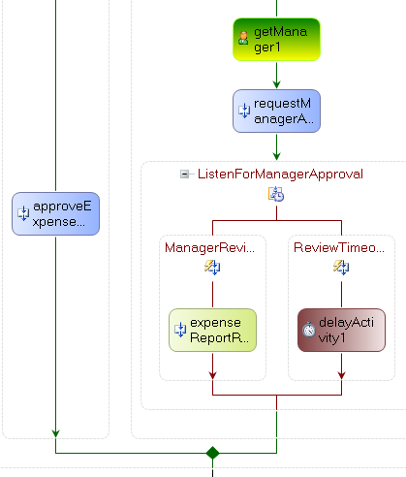

Task 3 – Approve or Reject the Expense Report

- Add an IfElse activity to the workflow definition below the expenseReportReviewed1 activity.
- In the properties window, change the (Name) property for the ifElseActivity1 activity to the value EvaluateReview.
- Select the left branch of the EvaluteReview IfElse activity.
- In the properties window enter or select values for the following properties:
  - (Name) - Enter the value IfApproved
  - Condition – Select CodeCondition from the drop-down list, indicating that this should be a code-based condition
- In the properties window, expand the Condition property, and for the child Condition property enter the value IfReportApproved_Condition. Your properties dialog will look like this.

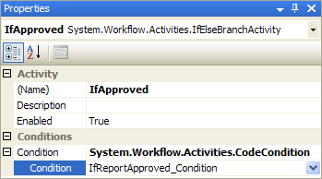

When you press enter the condition code handler will be added and shown in the code window.

- In the IfReportApproved_Condition event handler set the ConditionalEventArgs.Result property to the Boolean value stored in the reviewArgs.Review object’s Approved property:

Private Sub IfReportApproved_Condition(ByVal sender As System.Object, _
ByVal e As System.Workflow.Activities.ConditionalEventArgs)
e.Result = Me.reviewArgs.Review.Approved
End Sub

- Now double-click on the Workflow1.xoml in the solution explorer to show the Visual Studio workflow designer again.
- Select the right branch of the EvaluateReview IfElse activity and in the properties window, change the (Name) property for the branch to the value ElseDeclined.
- Your workflow definition should look like this:

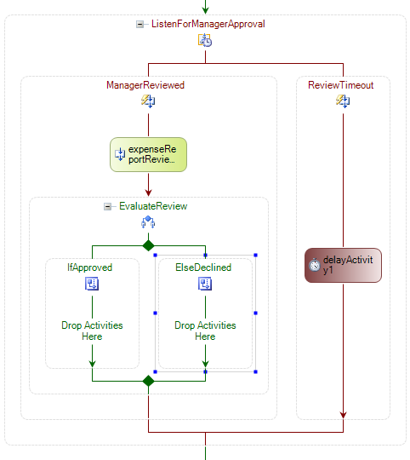

- Add a CallExternalMethod activity to the workflow definition within the IfApproved branch of the IfElse activity.
- Set the (Name) property of the CallExternalMethod activity to approveExpenseReport2. There is already an approveExpenseReport1 on the workflow.
- Choose the InterfaceType property first. Select ExpenseLocalServices.IExpenseService.
- Choose the MethodName property and select ApproveExpenseReport from the drop down list.
- Choose the report property and click the ellipsis to bind it to reportArgs.Report.
- Your workflow definition should look like this:

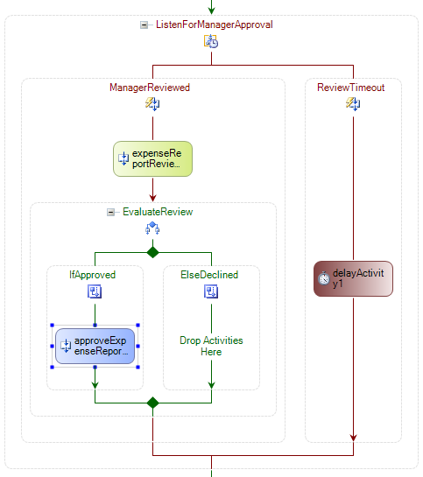

- Add a CallExternalMethod activity to the workflow definition within the ElseDeclined branch of the IfElse activity.
- Set the (Name) property of the new CallExternalMethod activity to rejectExpenseReport1.
- Choose the InterfaceType property first. Select ExpenseLocalServices.IExpenseService.
- Choose the MethodName property and select RejectExpenseReport from the drop down list.
- Choose the report property and click the ellipsis to bind it to reportArgs.Report.
- Your workflow definition should look like this:

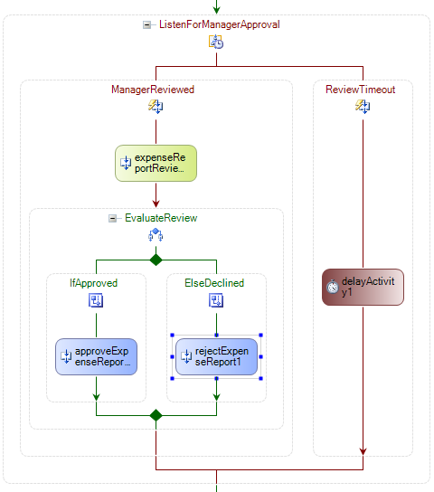

- Right click on the rejectExpenseReport1 activity and select Copy from the context menu.

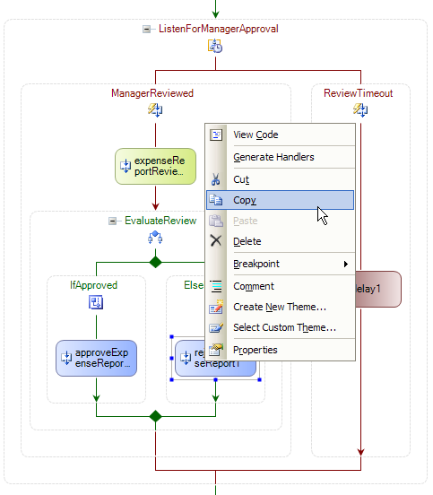

- Right click on the Visual Studio workflow designer below the delayActivity1 activity and select Paste from the context menu.
- Set the (Name) of the pasted activity to rejectExpenseReport2.
- Your workflow should now look like this:

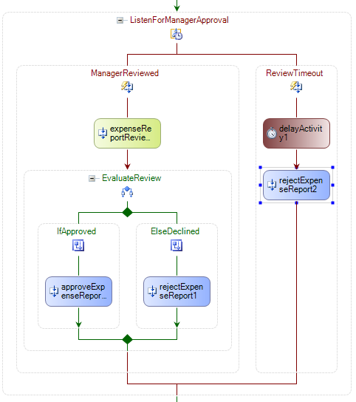

- Your Expense Reporting Workflow is now complete. Your completed workflow should look like the one in the following screenshot:

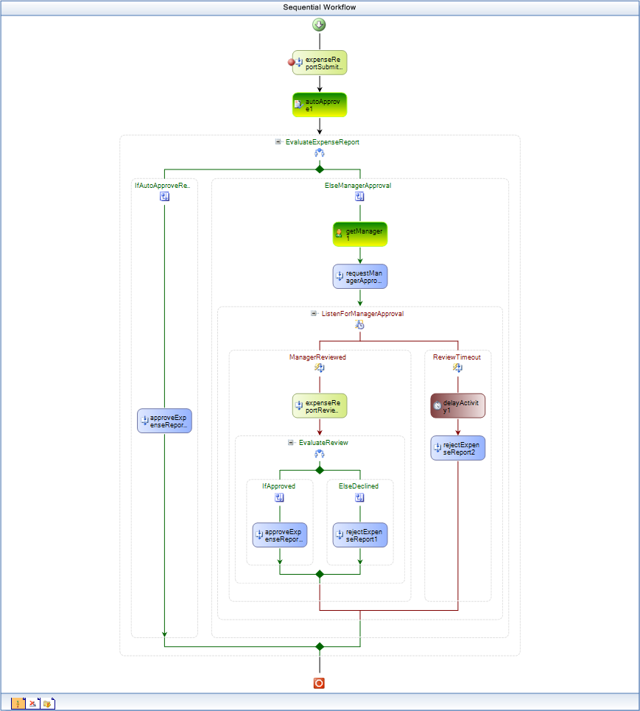

Task 4 – Test the Expense Reporting Workflow

- Next you will verify that the startup application is correct.
- Navigate to the Project | ExpenseWorkflows Properties menu.
- Click on the Debug tab.
- Ensure that the Start external program radio button is checked and the program is listed as:
C:\Windows Workflow Foundation\Labs\VB\Lab01\ExpenseWorkflows\ExpenseWorkflows\
bin\ExpenseHost.exe
- Double-click on the Workflow1.xoml file in the solution explorer to view the Visual Studio workflow designer.
- Set a breakpoint at the start of the workflow on the expenseReportSubmitted1 activity. The top of the workflow should look like this:

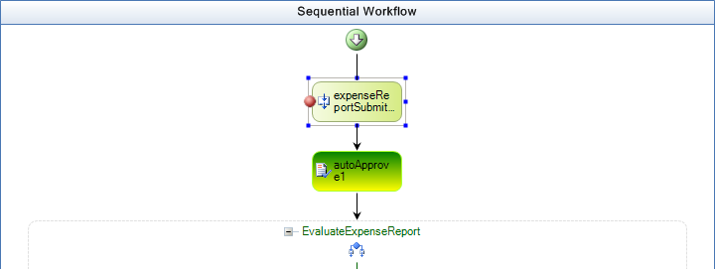

- Compile and run the ExpenseWorkflows project under the Visual Studio debugger by pressing F5 or selecting the Debug | Start Debugging menu command.
- The ExpenseHost will then start and display a console window.
- Run ExpenseApplication.exe from the following directory:

C:\Windows Workflow Foundation\Labs\VB\Lab01\Resources\ExpenseReporting\bin
- Run ManagerApplication.exe from the following directory:

C:\Windows Workflow Foundation\Labs\VB\Lab01\Resources\ExpenseReporting\bin

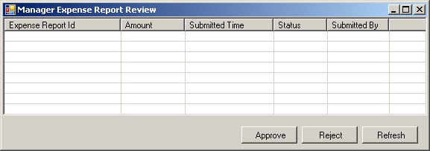

- Using the Expense Application, click the Submit Report button to create a new expense report and submit it to the workflow. A new workflow instance will be started and Visual Studio 2005 will break into debug mode at the expenseReportSubmitted1 activity.

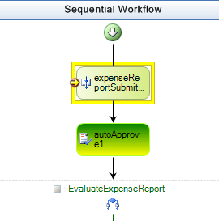

- You can continue the workflow using F5 or Debug | Continue. There is a 30 second delay until the review timeout.
- Now delete all breakpoints using Debug | Delete All Breakpoints and then press F5 to continue.
- Now you can submit multiple expense reports of different values.

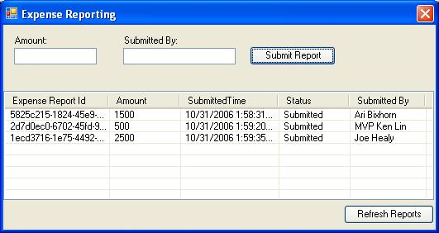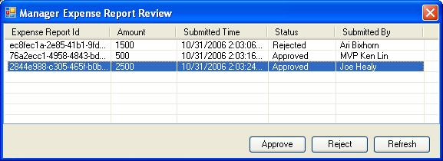

- Using the Manager application, click the Refresh button to refresh the list of expense reports.
- Select an expense report from the list and click the Approve button to approve the expense report.

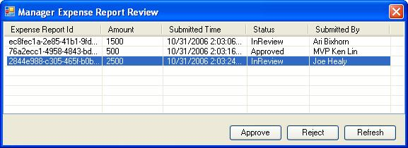

- Finally, using in the Expense Reporting application, click the Refresh button to refresh the changes. Keep in mind that if you wait for longer then 30 seconds from submitting the expense report, then it will automatically be rejected because of the delay activity that we added and configured in the workflow.

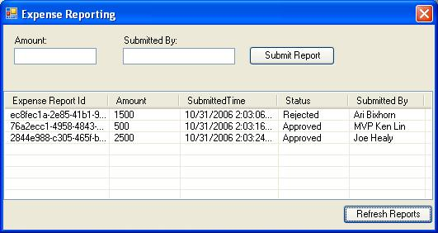

Lab Summary

In this lab you performed the following exercises.

- Create a Hello World workflow
- Receiving data into a workflow using parameters
- Using activating events, If/Else activity, and declarative conditions
- Using Listen, Delay, and custom event-based activities.

In this lab, you learned how to author sequential workflows using the Visual Studio workflow designer. You learned how to use several of the basic activities provided by Windows Workflow Foundation as well as some custom activities for receiving events into a workflow and interacting with the host application. Finally, you saw how workflows can be hosted in a variety of applications including console applications and Windows Forms applications.

